CREATING A BLOG APP:

Offered by **Smart Internz**



**TEAM ID:** LTVIP2023TMID08081

Balivada Reshma(20NM1A0412)-Team Leader

Bonthu Rashmitha(20NM1A0432)-Team Member

Boddapalli Pravallika(20NM1A0425)-Team Member

Dasari Pavitra(20NM1A0443)-Team Member

**INTRODUCTION:**

 Welcome to the Blog App Interface: Your Gateway to Limitless Insights!

****Simplicity meets functionality in our user-friendly design. With a sleek search bar at your fingertips, you can effortlessly navigate through a diverse collection of blogs. Scroll through captivating titles and delve into a world of inspiration, all presented with an elegant HTML and CSS layout. Discover the power of knowledge as you explore our curated selection of articles. Welcome to a seamless journey of discovery on the Blog App.

**PROJECT DESCRIPTION:**

Dive into a fully responsive web application, meticulously pieced together using JavaScript, CSS, HTML, and Bootstrap. Here, we are dedicated to delivering the latest blog posts across a spectrum of topics – from products and solutions to new technologies, projects, and management strategies. Our central theme revolves around presenting fresh ideas and cutting-edge innovations, all harmoniously hosted on a single, easy-to-navigate website. Embark on a journey of exploration and inspiration with us as we unveil the future, one blog at a time.

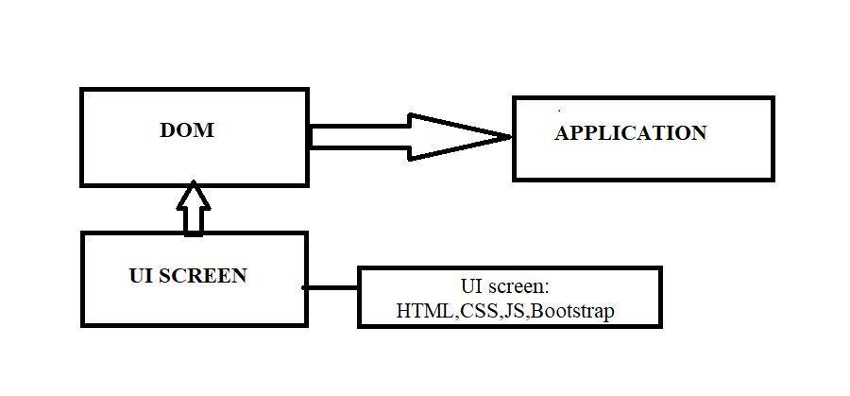**TECHNICAL ARCHITECTURE:**

**PROJECT OBJECTIVES:**

By the end of this project, you will be able to:

Responsive UI Development: Design an interactive user interface using HTML, CSS, and JavaScript that adapts seamlessly to various devices.

Task Management Functionality: Develop JavaScript features for adding, completing, and deleting tasks, enhancing user task management.

Status-based Task Viewing: Integrate filtering options to categorize and display tasks based on their completion status, improving task organization.

**PROJECT FLOW:**

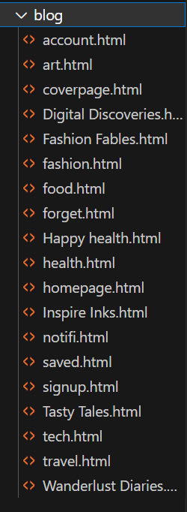

**PROJECT STRUCTURE:**

**1. Set up the project structure**

- Create a new project folder for the Blog App

- Inside the project folder, create the necessary files.

- Set up the basic HTML structure in the required file.

- Set up the required CSS structure in the required file.

- Set up the required JavaScript structure in the required file.

**2. HTML Code:**

* Contains the basic structure of the app’s user interface.
* Includes the CSS and JavaScript

The below figure 1 shows the HTML code used to create Blog App: 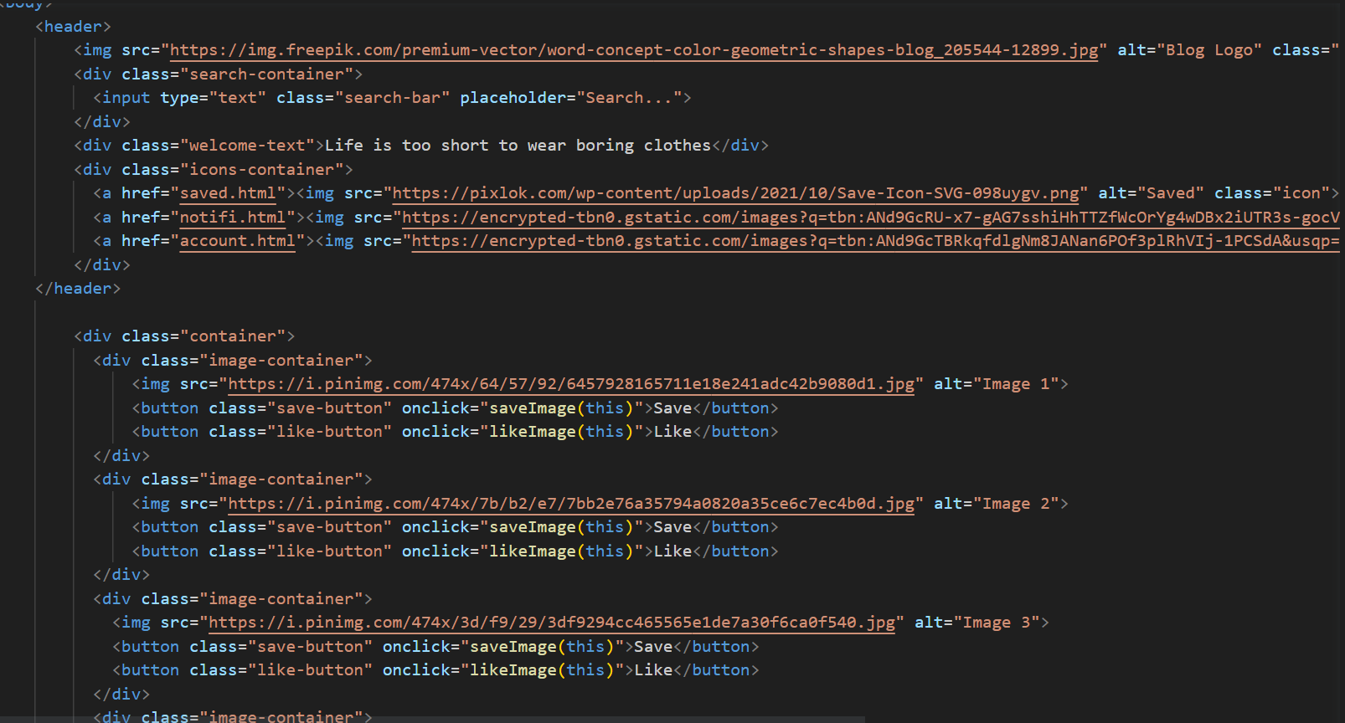

Figure 1: HTML Code

**3. CSS Code:**

* Defines the styling and layout of the user interface.
* Formats fonts, colours, backgrounds, buttons, and input fields.

The below figure 2 shows the CSS code to apply styles:

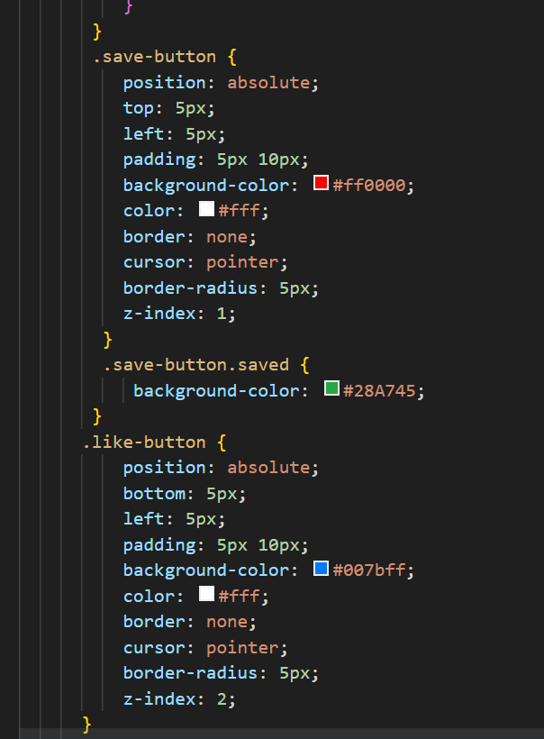

Figure 2: CSS Code

**4. JavaScript Code:**

* Implements the functionality of the app, handling user interactions and data retrieval.
* Contains event listeners to capture user actions, such as clicking the search button.

The below figure 3 shows the JavaScript code used to save the images from the blog pages. 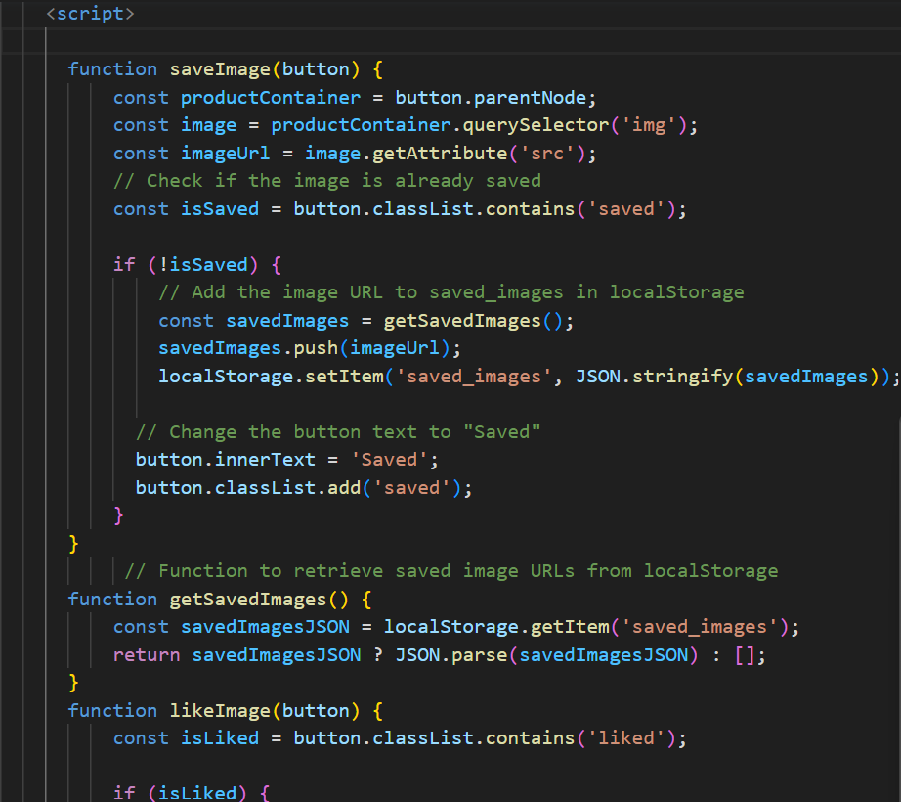

Figure 3: JavaScript

**STEPS TO CREATE TO-DO LIST APP USING STUDIO CODE:**

* Open Visual Studio code app.
* Go to extensions and install live server.
* Open file click on open folder and create a new folder.
* Add new file in explorer within code folder using extension .html
* Dump the HTML code in the given file.
* Dump the codes in the following files.
* Go to HTML code and right click to select live server.
* To execute the codes, Click on Go live
* Code starts debugging and output will be displayed.
* The first page shows the sign in and sign-up button.
* After logging in the home page will be displayed.
* Then various blogs are displayed on the home page
* In the search bar we search our favourite blogs
* In the saved button we can see the saved images.
* In the notifications we get notified.
* In the account button we get to see the username.

**PROJECT OUTCOME:**

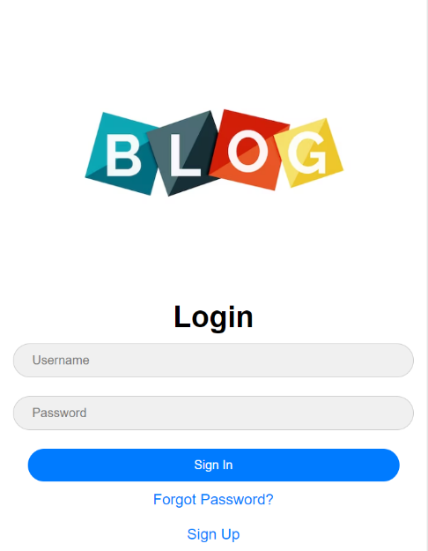

The above image is sign in / signup page

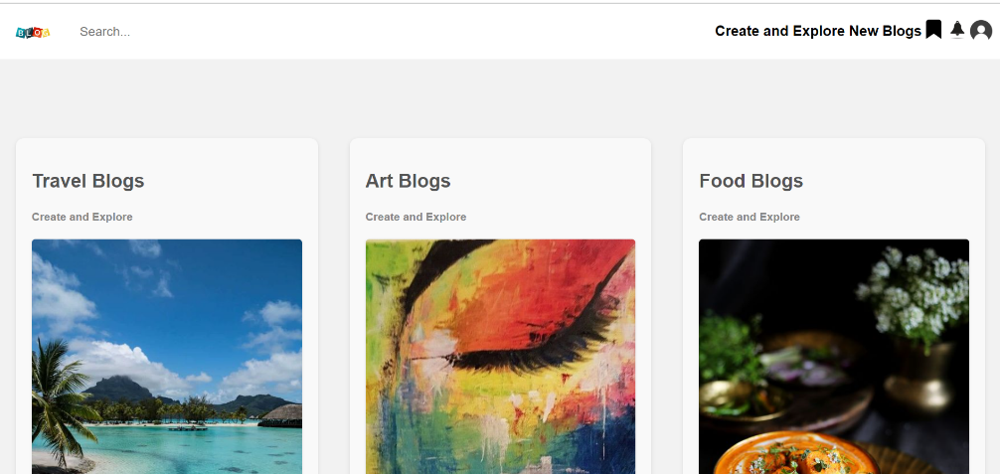

The above image is the home page

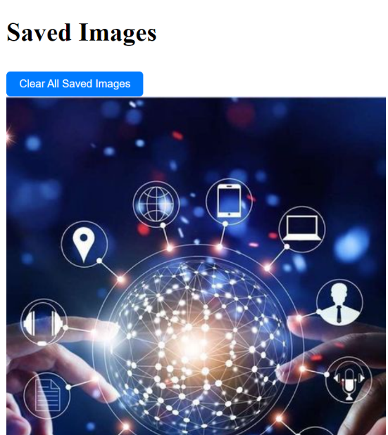

The above image shoes the saved pictures.

**CONCLUSION:**

Our dynamic blog app offers a diverse collection of blogs spanning travel, food, health, fashion, and more. With easy access to personalized content, seamless search, saved favourites, notifications, and profile management, the app provides a comprehensive platform for readers to explore, learn, and connect. Whether indulging in culinary delights, embarking on virtual adventures, staying updated with trends, or prioritizing well-being, our app fosters creativity, knowledge, and a sense of community. Join us in embracing innovation and inspiration through the power of words and visuals. Happy blogging!

**GITHUB LINK:**

<https://github.com/Reshma-Balivada/Creating-a-Blog-App>